SOLAR CELLS

High-performance perovskite/ Cu(In,Ga)Se2 monolithic tandem solar cells

Qifeng Han1*†, Yao-Tsung Hsieh1†, Lei Meng1†, Jyh-Lih Wu2, Pengyu Sun1, En-Ping Yao1, Sheng-Yung Chang1, Sang-Hoon Bae1, Takuya Kato2, Veronica Bermudez2, Yang Yang1*

The combination of hybrid perovskite and Cu(In,Ga)Se2 (CIGS) has the potential for realizing high-efficiency thin-film tandem solar cells because of the complementary tunable bandgaps and excellent photovoltaic properties of these materials. In tandem solar device architectures, the interconnecting layer plays a critical role in determining the overall cell performance, requiring both an effective electrical connection and

high optical transparency. We used nanoscale interface engineering of the CIGS surface and a heavily doped poly[bis(4-phenyl)(2,4,6-trimethylphenyl)amine] (PTAA) hole transport layer between the subcells that preserves open-circuit voltage and enhances both the fill factor and short-circuit current. A monolithic perovskite/CIGS tandem solar cell achieved a 22.43% efficiency, and unencapsulated devices under ambient conditions maintained 88% of their initial efficiency after 500 hours of aging

under continuous 1-sun illumination.

C

perovskite front cell, maintaining the integrity of the original CIGS device structure to preserve its superior efficiency, and a well-designed ICL with a smooth surface.

We developed a transport top electrode, suit- able ICL, and hole-transporting layer (HTL) for our tandem device and present a high-performance monolithic perovskite/CIGS tandem solar cell without modification of the CIGS device struc- ture, i.e., preserving its TCO layers (i-ZnO and boron-doped ZnO (BZO) layers). For the two sub- cells, we applied a semitransparent perovskite with a bandgap of 1.59 eV as the front cell, and CIGS with a bandgap of 1.00 eV as the rear cell. The certified tandem device achieves a PCE of 22.43%.

To design a functional ICL, the CIGS device surface must be taken carefully into considera- tion. In this study, BZO is used as the top layer of the CIGS device, which has a surface roughness of about 60 nm, and the maximum vertical dis- tance (VD) of the natural BZO layer texture can reach more than 250 nm (Fig. 1A). We speculate that such considerable roughness and VD may originate from the difference between peaks and valleys of the CIGS absorber layer. In addition, inhomogeneous nucleation of the bottom CdS buffer layer can also enhance BZO roughness, as

onstructing a tandem solar cell with min- imal thermalization losses has proved to be a successful approach for overcom- ing the Shockley-Queisser limit of a single- junction cell. This device can realize the



Downloaded from <http://science.sciencemag.org/>on March 6, 2019

superposition of the open-circuit voltage (*V*OC) of both subcells while simultaneously preserv- ing high short-circuit current (*J*SC) by using photoactive materials with complementary ab- sorption characteristics to harvest a broader solar spectrum (*1*–*9*). Thin-film photovoltaic (PV) technologies applying various inorganic and organic photoactive materials have attracted considerable attention (*10*–*13*). Perovskite com- pounds debuted as an efficient light harvester for photoelectrochemical cells (*14*) and later evolved from liquid to solid-state junctions that enabled a large boost in performance (*15*, *16*), reaching power conversion efficiencies (PCEs)

>22% in just 5 years (*17*–*21*). However, the well- established Cu(In,Ga)Se2 (CIGS) solar cells have also yielded a maximum PCE >22% (*22*, *23*). Both PV materials have widely tunable band- gaps, from 1.0 to 1.7 eV for CIGS and 1.2 to 2.3 eV for perovskite (*24*–*29*). These characteristics provide the capability to achieve the highest ef- ficiency of double-junction tandem solar cells, where the ideal rear and front cells should have bandgaps of 1.1 and 1.7 eV, respectively (*30*, *31*).

Several studies on four-terminal mechanically stacked perovskite/CIGS tandem solar cells have

1Department of Materials Science and Engineering, University of California–Los Angeles, Los Angeles, CA 90095, USA.

2Atsugi Research Center, Solar Frontier K.K., Atsugi,

Kanagawa 243-0206, Japan.

*Corresponding author. Email: [yangy@ucla.edu](mailto:yangy@ucla.edu) (Y.Y.); qfhan@ ucla.edu (Q.H.) †These authors contributed equally to this work.

been reported (*32*–*34*). The highest efficiency for this type of perovskite/CIGS architecture is 22.1%, obtained with a 19% PCE CIGS rear cell and a 16% PCE perovskite front cell (*35*). By contrast, few studies on two-terminal perovskite/ CIGS tandem solar cells have been reported, even though a two-terminal monolithic tandem archi- tecture is potentially preferable for industrial applications because of the reduced number of electrodes and transparent conducting layers necessary. In 2015, Todorov *et al*. reported a two- terminal perovskite/CIGS tandem solar cell with an efficiency of 10.9%, which was much lower than the performance of the individual CIGS or perovskite subcells (*36*). There are three main reasons for this inferior efficiency. First, optical losses can be caused by top opaque metal elec- trodes. Second, the intrinsic ZnO (i-ZnO) and aluminum-doped ZnO (AZO) layers of typical CIGS cells were removed as zinc oxides can cause deterioration of the perovskite layer. How- ever, by doing so, the original CIGS device architecture was compromised and elimination of the ZnO layer would inevitably degrade the CIGS device performance. Third, the fill factor (FF) was reduced to 60% because of a high series resistance (*R*s) caused by poor contact between the two subcells.

The smoothness of the interconnecting layer (ICL) is equally crucial to create a reliable con- tact between the two subcells, because the planar perovskite solar cell is composed of several func- tional layers, with thicknesses from a few tens to hundreds of nanometers, that are sensitive to substrate roughness. Thus, in order to take advan- tage of these two technologies for two-terminal tandem solar cells, the challenge is to ensure the integrality of the two subcells, which relies heavily on the transparent top electrode of the

shown in fig. S1.

The maximum VD is comparable to the length of the perovskite absorber layer, which is usu- ally between 300 and 600 nm, and even larger than the thickness of the perovskite charge- transporting layers. With these large VDs, it becomes challenging to stack the perovskite solar cell on top of the CIGS with a homogeneous layer-by-layer structure. The rough BZO surface would cause perovskite subcell failure as the BZO peaks and rods can easily entangle the functional layers in the perovskite device to induce electri- cal shorting pathways between the top contact of perovskite subcell and the BZO layer. We con- firmed that the nature of the CIGS device surface is problematic for building a smooth ICL on top of it, and hence the ICL roughness is pivotal in realizing high-performance perovskite/CIGS tan- dem solar cells.

To address this issue, we first deposited an indium tin oxide (ITO) layer, followed by chem- ical mechanical polishing (CMP) to smooth out the ITO surface. The addition of a sufficiently thick ITO layer can serve as a buffer layer for the CMP process to level out the huge VD of the BZO layer. The ITO layer was polished with a commercialized SiO2 slurry. The detailed param- eters for CMP processing are provided in the sup- plementary materials (*37*, *38*). After polishing, the maximum VD of the ITO layers was reduced to 40 nm (Fig. 1B), which rendered the ITO surface smooth enough for subsequent fabrication of the functional perovskite front cell. Notably, the CMP process did not polish the BZO layer such that we retained the original CIGS solar cell structure (Fig. 1C). Furthermore, the BZO work function (−4.0 eV, fig. S2) was lower than that of poly[bis(4-phenyl)(2,4,6-trimethylphenyl)amine] (PTAA) (−5.1 eV, the HTL of perovskite subcell),

Fig. 1. Effects of CMP on CIGS surface and resulting performance of CIGS solar cells. (A) Atomic force microscopy (AFM) image of the CIGS surface before CMP polishing. (B) AFM image of the CIGS surface after CMP polishing. (C) Cross-sectional SEM images of the CMP processing on

the CIGS surface. (D) *J*-*V* curves of original CIGS solar cells and after CMP polishing with a step size of 0.02 V and a scan velocity of 0.1 V/s, measured under AM1.5G illumination. (E) EQE of original CIGS solar cells and after CMP polishing.

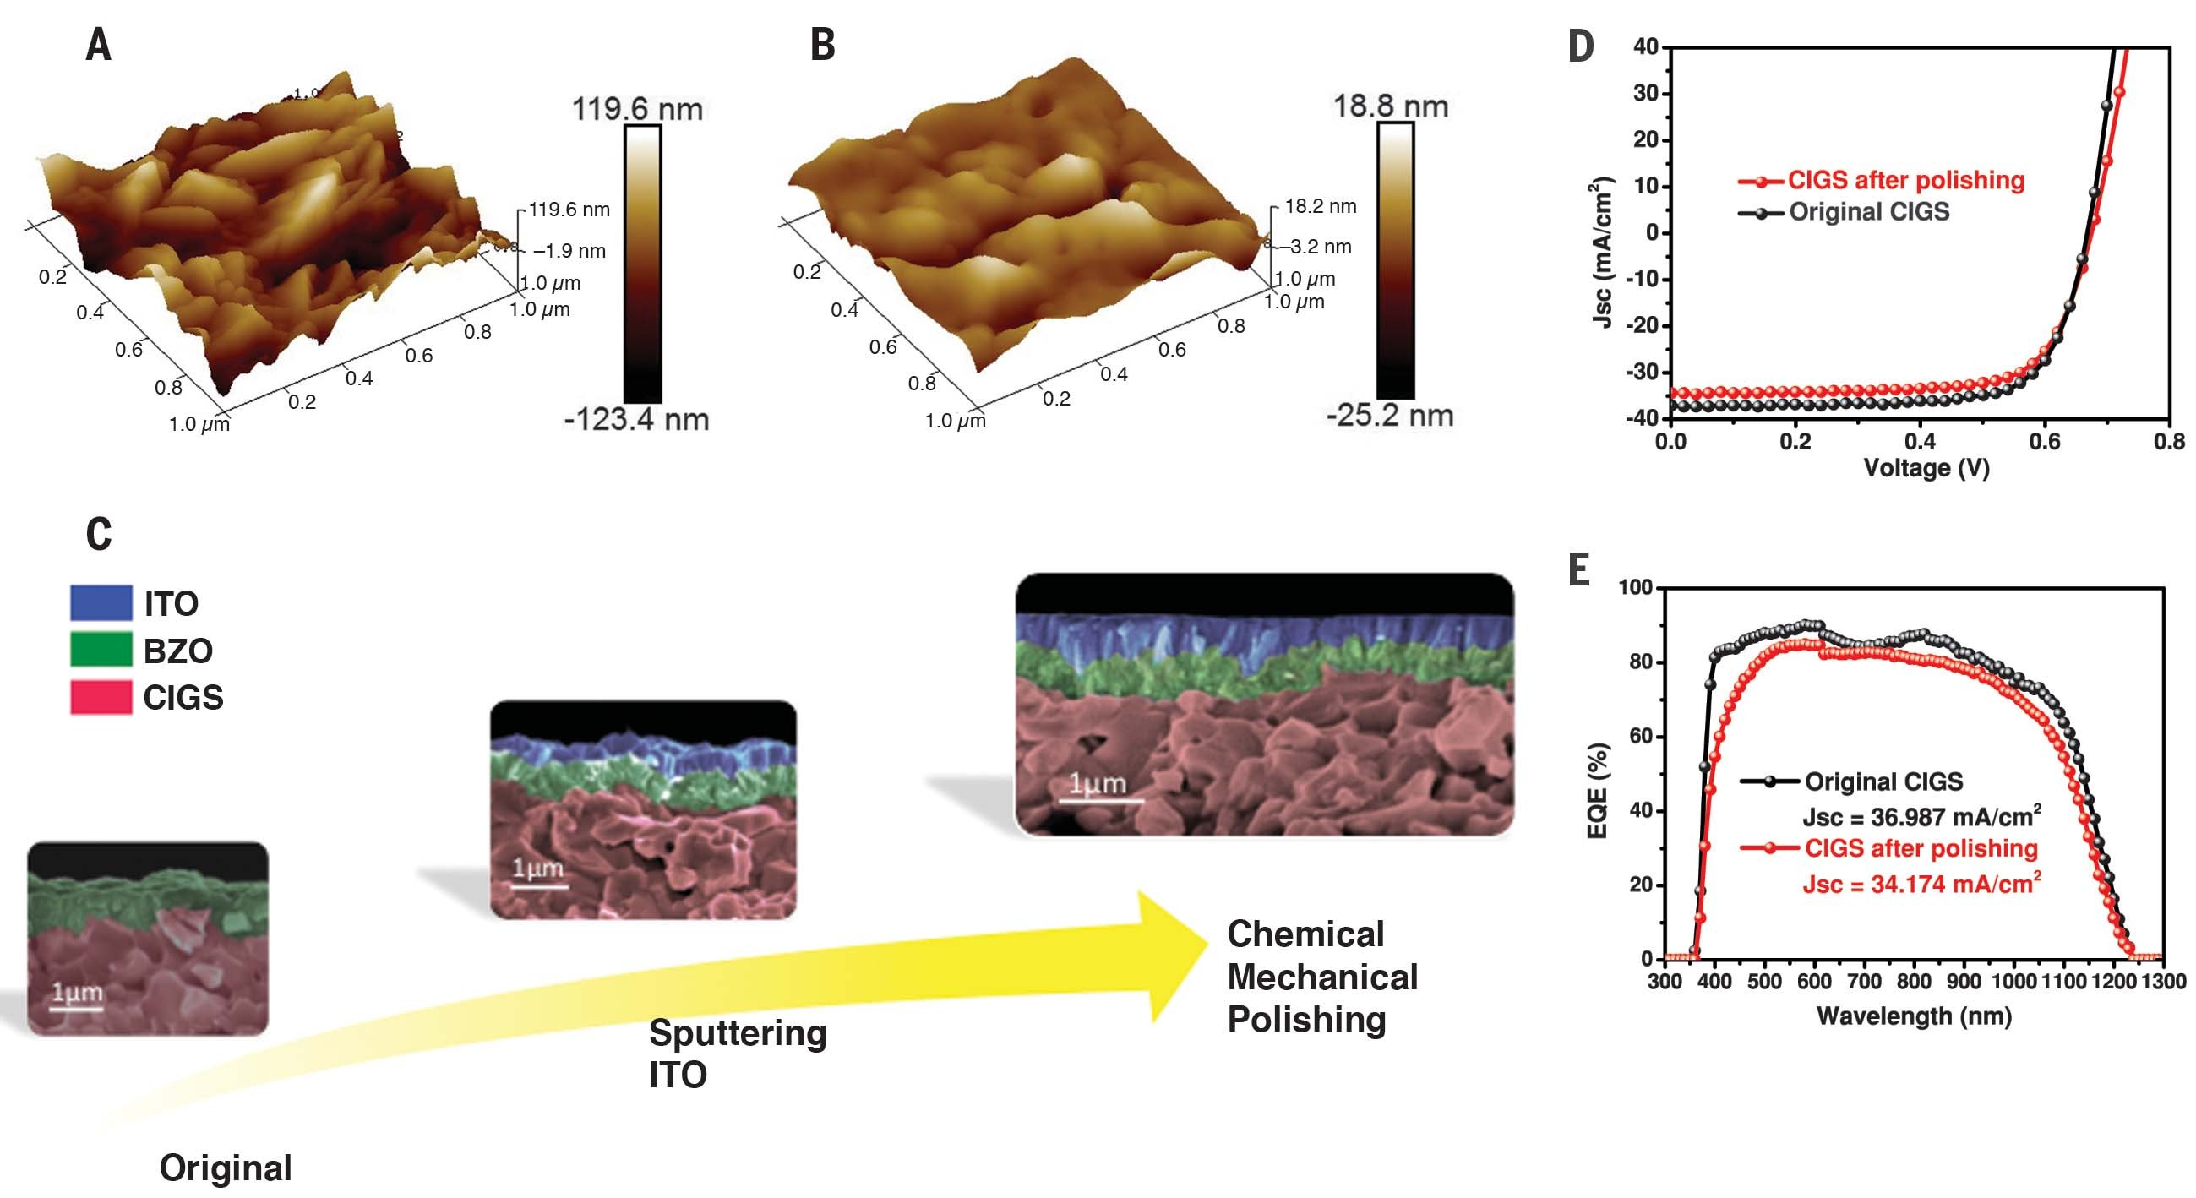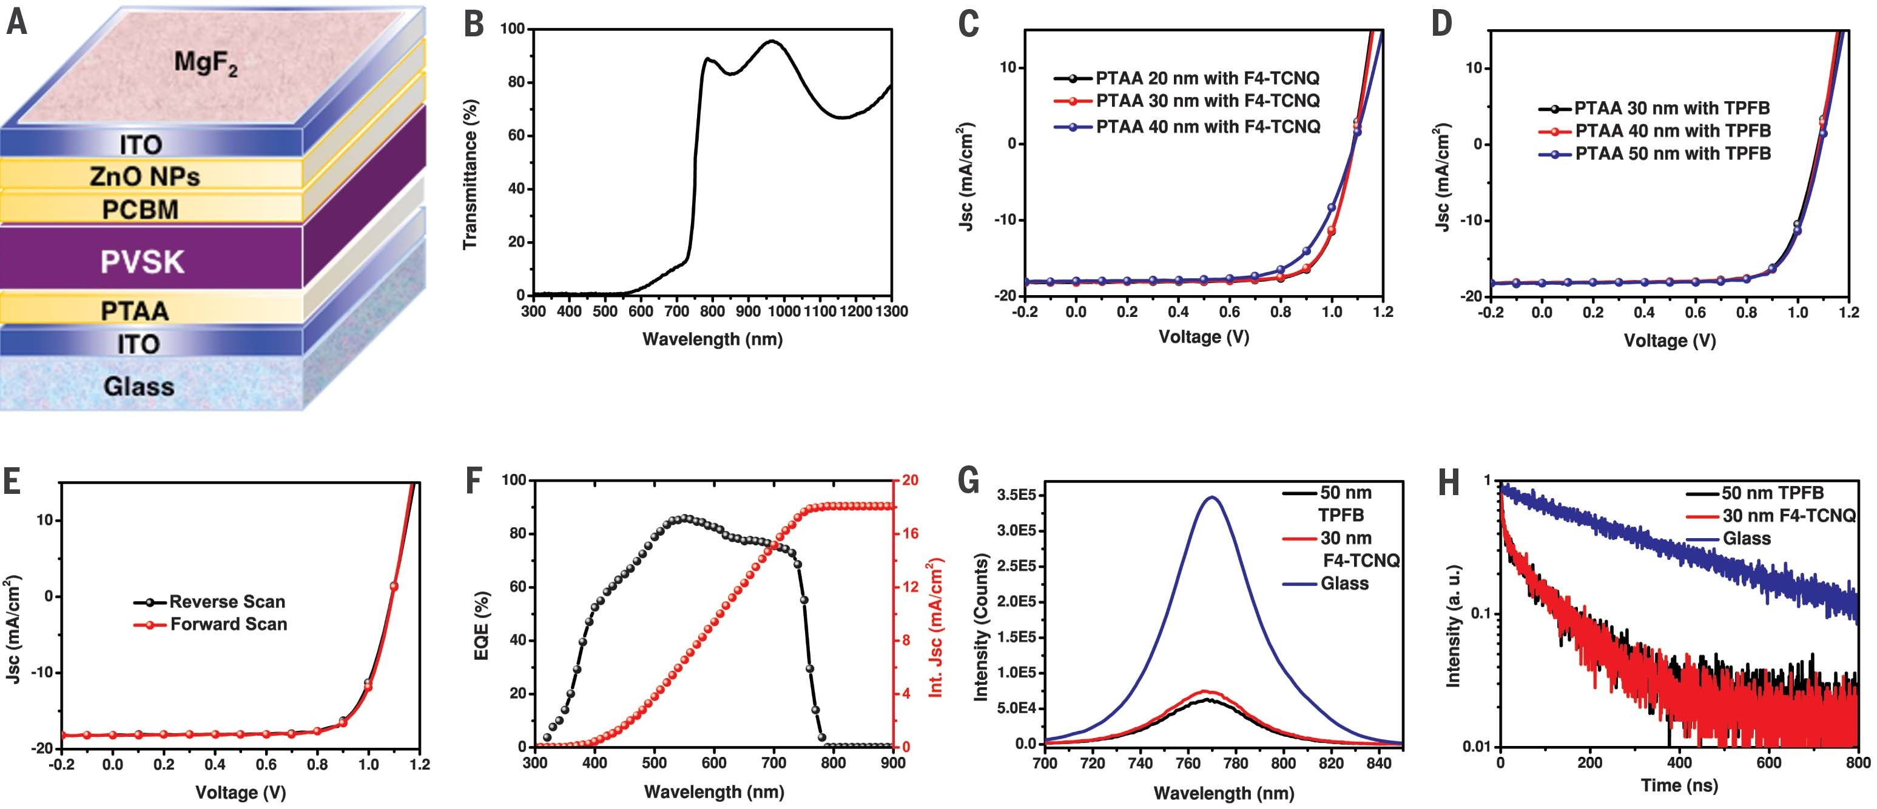

Downloaded from <http://science.sciencemag.org/>on March 6, 2019

Fig. 2. Performance of the semitransparent Cs0.09FA0.77MA0.14Pb(I0.86Br0.14)3 perovskite solar cell. (A) Schematic of the semitransparent single junction perovskite solar cell. (B) Transmittance spectrum through the entire device stack. (C) *J*-*V* curves of the perovskite solar cell using different thicknesses of 1 wt % F4-TCNQ–doped PTAA with illumination through the MgF2 side.

(D) *J*-*V* curves of the perovskite solar cell using different thicknesses of 10 wt % TPFB-doped PTAA with illumination through the MgF2 side. (E) *J*-*V* curves

in the forward (−0.1 to 1.2 V) and reverse (1.2 to −0.1 V) scan of the perovskite solar cell using 10 wt % TPFB-doped PTAA with illumination through the MgF2 side. (F) EQE spectrum of the perovskite solar cell using 10 wt % TPFB-doped PTAA. The *J*SC calculated from the EQE curve is 18.062 mA/cm2.

1. Photoluminescence of the perovskite layer on top of glass and PTAA doped with 1 wt % F4-TCNQ or 10 wt % TPFB. (H) TRPL data for the perovskite layer in contact with glass and PTAA doped with 1 wt % F4-TCNQ or 10 wt % TPFB.

Fig. 3. Performance of the perovskite/CIGS tandem cells.

* 1. Schematic and cross-sectional SEM image of the monolithic perovskite/CIGS tandem solar cell. (B) *J*-*V* curve (NREL-certified; see

fig. S8) and efficiency at the maximum power point (inset) of the champion tandem device. (C) EQE spectra for the subcells of the monolithic perovskite/CIGS tandem solar cell. (D) Stability test of the monolithic perovskite/CIGS tandem solar cell. The unencapsulation device maintained 88% of their initial PCE after 500 hours of aging under continuous

1-sun illumination and maximum power point tracking at 30°C ambient environment. The inset shows that the device can recover 93% of its initial performance after a 12-hour resting period without load and illumination.

which causes a large contact potential barrier. This ITO layer can efficiently modify the surface work function to create a better ohmic contact for hole transportation. On the basis of our ex- periments, a 300-nm ITO layer proved sufficient to carry out the CMP process and fully cap the BZO peaks and rods.

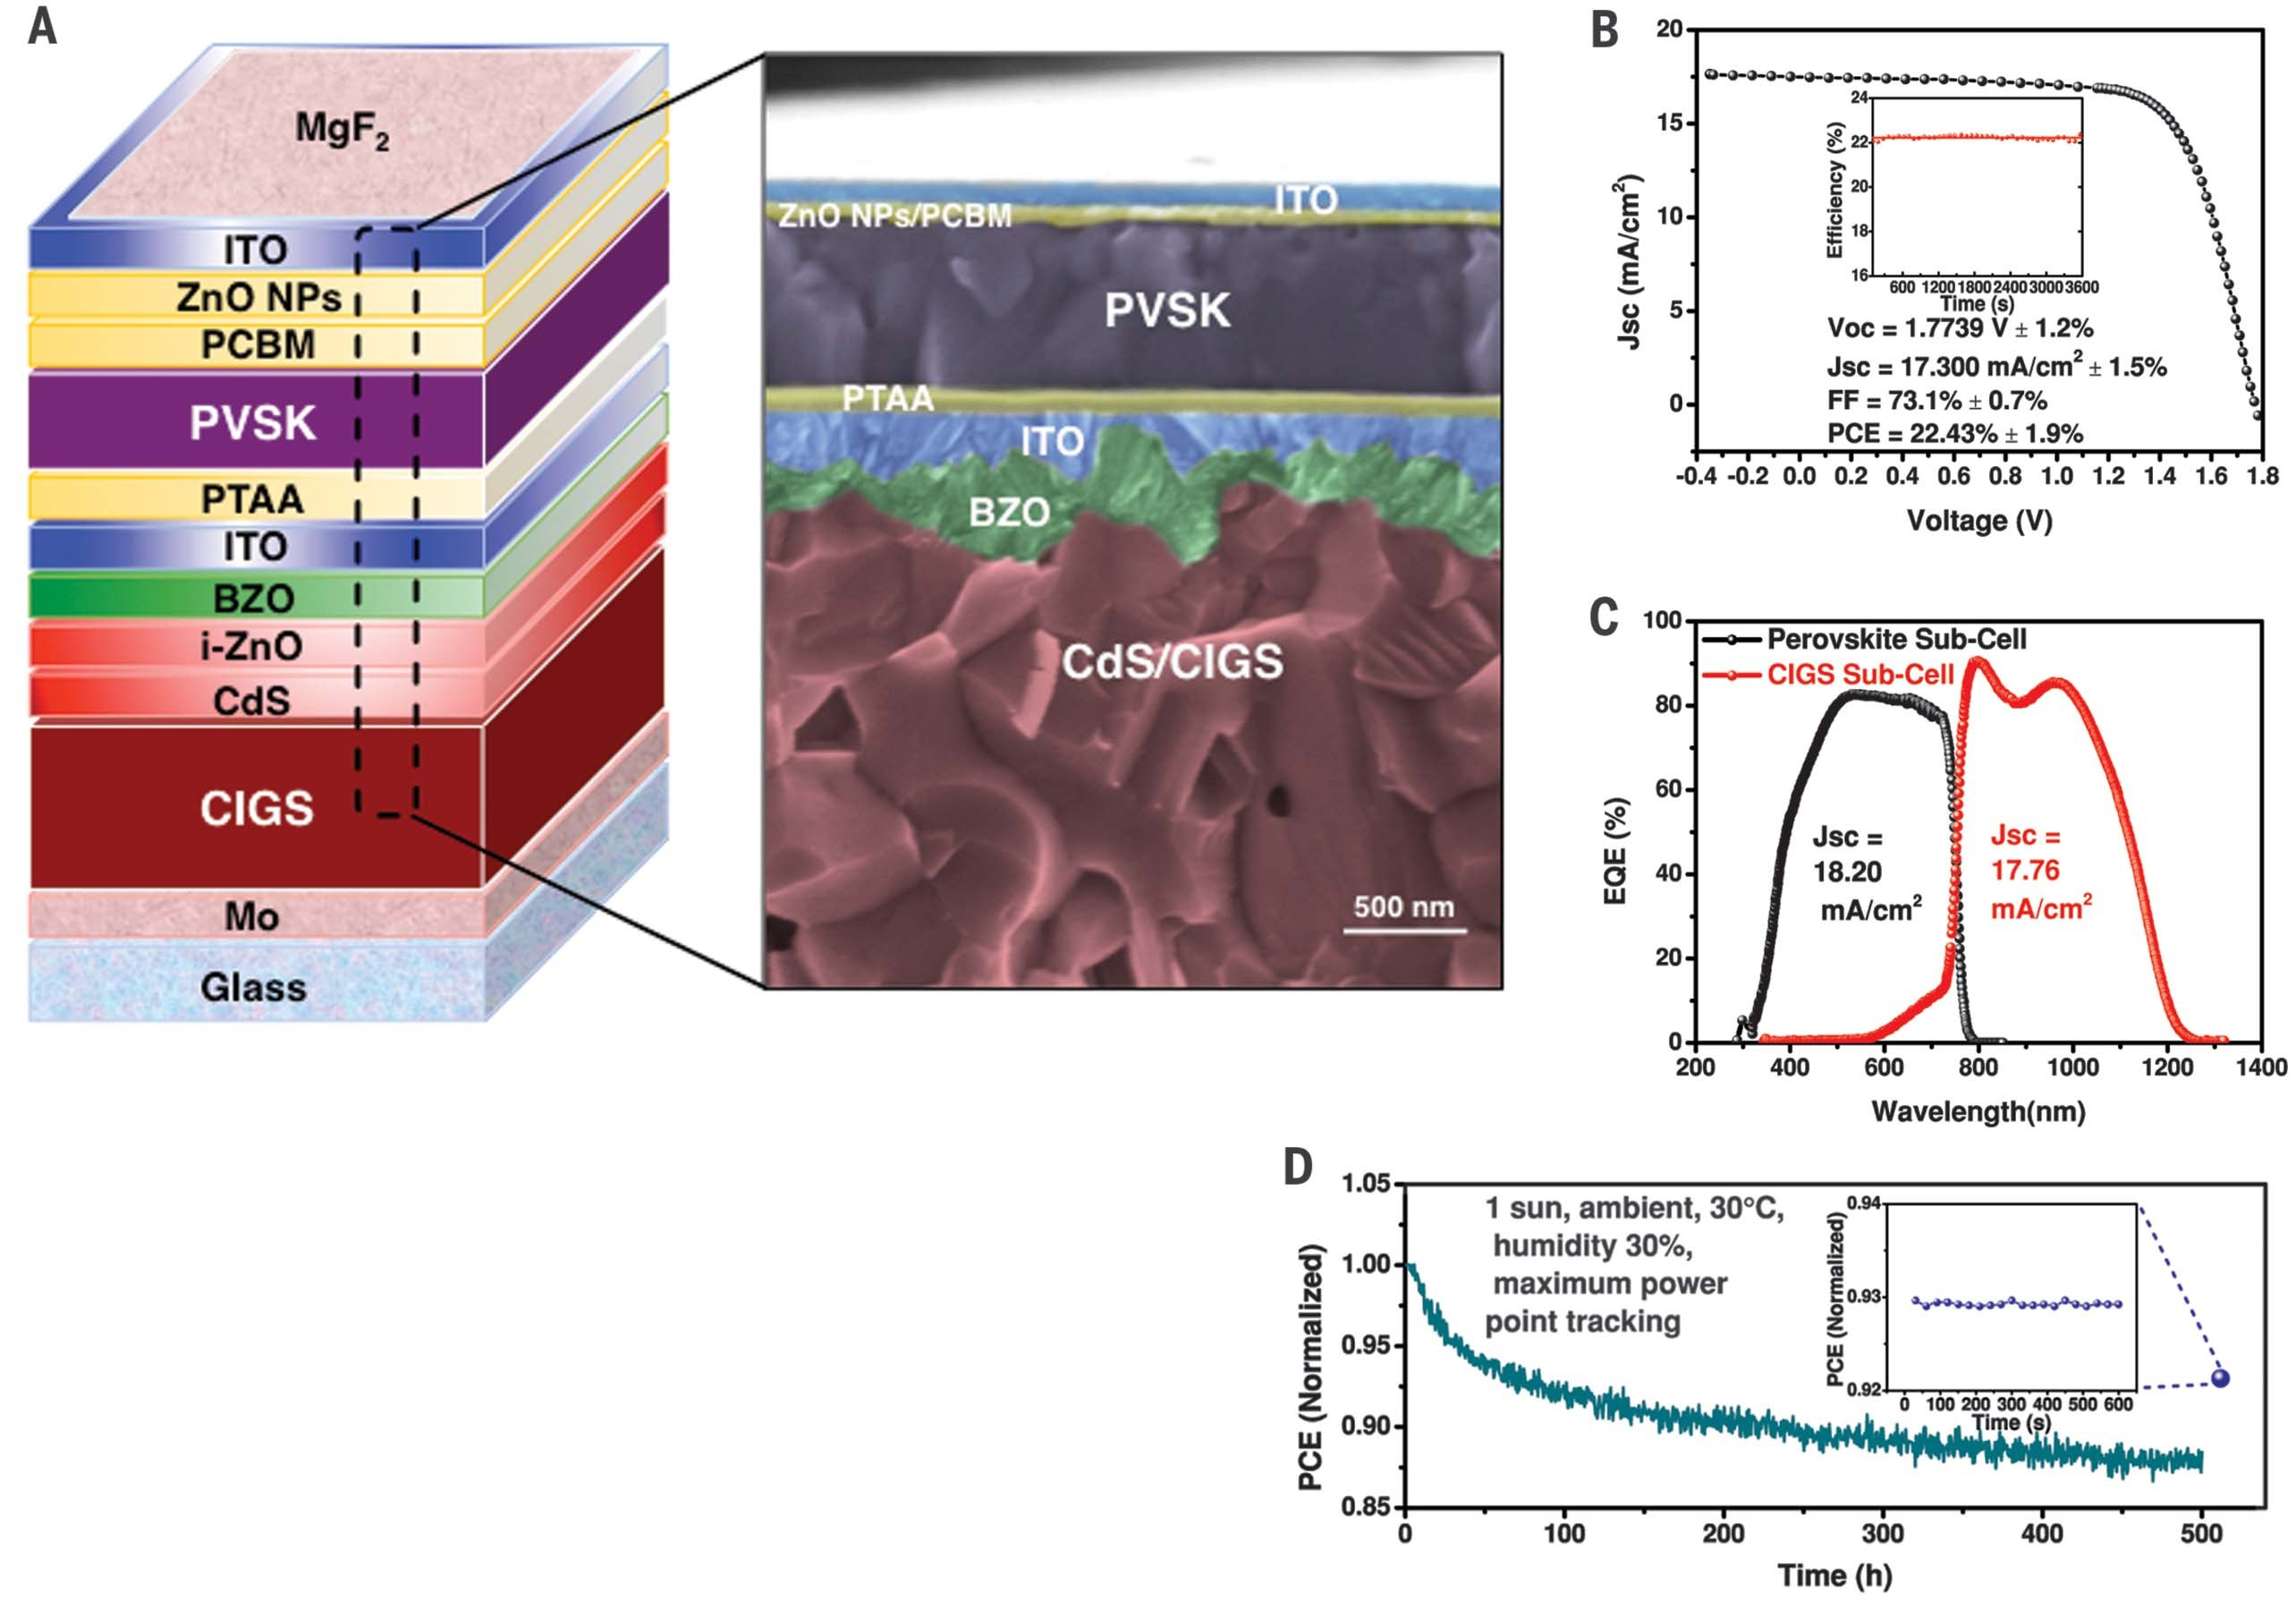

Downloaded from <http://science.sciencemag.org/>on March 6, 2019

The current density–voltage (*J*-*V*) curves of the stand-alone original and polished CIGS solar cells are compared in Fig. 1D, and the data are shown in Table 1. The *V*OC remained constant, which fur- ther implies that CMP processing did not damage the CIGS device structure. The *J*SC decreased from

37.10 to 34.34 mA/cm2 for the ITO-polished de- vice. We attributed the *J*SC drop to the additional light absorption by the ITO layer, as we observed with the smaller external quantum efficiency (EQE) intensity across the entire response region (Fig. 1E). The EQE of the ITO-polished device was lower than that of the original CIGS device at wavelengths from 400 to 500 nm. This response region corresponds to the smaller bandgap of ITO compared to BZO and provides evidence that the ITO layer absorbed a fraction of the incident light. However, the ITO absorption in the short-wavelength region was negligible as the CIGS subcell is designed as a rear cell in the tandem device structure. After polishing, the FF decreased from 74.7 to 72.4%. The FF reduction was mainly induced by the *R*s increase induced by mediocre ITO lateral conductivity rather than the shunt resistance decrease (Fig. 1D). However,

because this ITO layer is used as the ICL for the tandem solar cell, the lateral conductivity will not affect the charge carrier transportation be- tween the front and rear subcells. After polishing the ITO layer of the CIGS device, the PCE was re- duced from 18.73 to 16.76%. If we exclude the FF deficit, the current loss was only 1.386 mA/cm2 in the wavelength region from 750 to 1250 nm.

We fabricated a semitransparent perovskite solar cell with an inverted structure (i.e., p-i-n) (Fig. 2A). Instead of using a metal electrode, we used a 100-nm ITO layer as the top contact in this structure to allow for sufficient light trans- mission (*39*). Various bandgaps of perovskites were tried in order to achieve current matching between the two subcells in the monolithic cell, and the best performance was achieved with a composition of Cs0.09FA0.77MA0.14Pb(I0.86Br0.14)3, which had a bandgap of 1.59 eV from ultraviolet- visible (UV-vis) measurements (fig. S4). Accord- ing to the optical simulation results (fig. S6), a 600-nm perovskite layer is needed to provide adequate current density to match the CIGS rear-cell current density. The average transmit- tance of the semitransparent perovskite cell in the wavelength region between 770 and 1300 nm is >80% (Fig. 2B), allowing most of the long-wavelength light to be absorbed by the CIGS rear cell. The transmittance gradually decreased from 770 to 550 nm, and the light was fully absorbed by the perovskite cell below 550 nm.

The thickness and coverage of the first layer on top of the ICL play a critical role for tandem device performance because the planar perov- skite device structure has a limited tolerance to the substrate roughness. Given that the polished ICL still preserved about 40 nm for its VD, we studied the solar cell performance versus the HTL thickness by using PTAA as the HTL and two different molecules, 2,3,5,6-tetrafluoro-7,7,8,8- tetracyanoquinodimethane (F4-TCNQ) and 4-isopropyl-4'-methyldiphenyliodonium tetrakis (pentafluorophenyl)borate (TPFB), as dopants to enhance the HTL conductivity. We deposited PTAA with a low-temperature annealing process (110°C) to avoid damage to the rear CIGS solar cell (*40*–*42*). The *J*-*V* curves of semitransparent devices using F4-TCNQ and TPFB with differ- ent thicknesses measured under 100-mW/cm2 illuminations are shown in Fig. 2, C and D, re- spectively, and the corresponding device param- eters are summarized in Table 2.

With the same concentration of F4-TCNQ, the device performance obtained by applying 30 nm PTAA is similar to that achieved with 20 nm PTAA; however, the *R*s increased when the PTAA reached 40 nm, which led to a FF and PCE reduc- tion. The best device performance was achieved by using 20 nm F4-TCNQ–doped PTAA that gave a *V*OC of 1.084 V, *J*SC of 18.10 mA/cm2, and FF of 75.6%, leading to an overall device efficiency of 14.83%. The desired F4-TCNQ/PTAA ratio was 1 weight % (wt %), and increasing the F4-TCNQ concentration did not

Table 1. Performance of CIGS solar cells before and after CMP polishing.

Device configuration

Table 2. Performance of perovskite solar cells using different dopants.

more desirable than conventional solution pro- cess to prevent shunt pathways and improve interface contacts (*39*). Lastly, use of a higher PCE for the CIGS subcell is needed, especially considering that the limiting current could be in- creased by tailoring the CIGS bandgap in our case. In addition to a high PCE, long-term stability is another crucial benchmark for industrialization of perovskite solar cells. Several aging routines have been suggested to estimate a conclusive stability in which the ion migration effects are excluded (*47*, *48*). We monitored the unencap- sulated tandem device performance by aging for

500 hours under continuous 1-sun illumination

*V*OC (V) *J*SC (mA/cm2) FF (%) PCE (%)

O.. ..r..i.g..i..n..a.. .l..C.. ..I.G.. .S........................................................................0.....6...7..6...........................3...7....1..0.............................7..4.. ...7....................1..8.....7..3....... C.. ..I.G.. .S.....s..o...l.a..r....c..e...l.l a...f.t..e..r....I.T...O....p...o...l.i.s..h.. .i.n...g... ..0.....6...7..4 ..3...4.. ...3...4... 72.. ...4.... .1..6.....7..6..

Device configuration HTL thickness (nm)

*V*OC

(V) *J*SC

(mA/cm2) FF (%) PCE (%)

and maximum power point tracking at 30°C am- bient environment. The device started with 22.0%

Perovskite solar cell using

F4-TCNQ–doped PTAA as HTL

..............2..0.............................1....0... 8...4....................1..8.....1..0...................7..5.....6.............1..4....8.. .3......

..............3..0.............................1....0... 8...6....................1..8.....1..2...................7..4.....5.............1..4....6.. .6......

PCE and retained >88% of its initial efficiency after aging, and it recovered 93% of its initial PCE

.........................................................................................4..0..............................1....0...8..6....................1..8.....0.. .1..................6...7....6.............1..3.....2..2......

..............3..0..............................1....0.. .8..3....................1..8.....1..4...................7..4.....0.............1..4.....5..4......

after being kept in the dark for 12 hours without load (shown in Fig. 3D). We believe that the top

Perovskite solar cell using TPFB-doped PTAA as HTL

..............4..0.............................1....0... 8...4....................1..8.....1..3...................7..4.....9.............1..4.....7..2......

..............5..0..............................1....0.. .9.. .1...................1..8.....1..5...................7..5.....5.............1..4.....9..5......

.5..0.....(..f.o.. .r..w...a..r..d....s.. .c..a...n..)... .1....0...9..2.. 1..8.....1..4 75.....3.... .1..4.....9..2....

transparent metal oxide layers (composed of ZnO nanoparticles and sputtered ITO) can ef- fectively resist moisture ingress (*39*, *49*), so that this structure can help the perovskite compounds remain stable without severe degradation.

decrease the *R*s because F4-TCNQ aggregates within the PTAA film. The *J*-*V* curves of the de- vices with different F4-TCNQ doping levels in the 30-nm PTAA layers are presented in fig. S7, and their device data are summarized in table S1.



Downloaded from <http://science.sciencemag.org/>on March 6, 2019

The *J*-*V* curves of the perovskite device using TPFB-doped PTAA (TPFB/PTAA = 10 wt %) were less sensitive to HTL thickness. The best device had 50-nm PTAA, with a *V*OC of 1.091 V, *J*SC of

18.15 mA/cm2, FF of 75.5%, and PCE of 14.95%. The high FF of this device resulted from the *R*s reduction from the HTL, in which the TPFB- doped PTAA has a higher conductivity than the F4-TCNQ-doped PTAA.

The semitransparent perovskite device using TPFB-doped PTAA was scanned from positive to negative (reverse scan) and negative to positive (forward scan) voltages with a step size of 20 mV and a delay time of 0.2 s for each data point in the *J*-*V* measurement (Fig. 2E). The photocurrent hysteresis is negligible as the perovskite grain boundaries are well passivated by [6,6]-phenyl- C61-butyric acid methyl ester (PCBM), which agrees with other reported results (*43*, *44*). EQE data (Fig. 2F) for the semitransparent perovskite cell show an offset position at 780 nm, which was consistent with the UV-vis results. The integrated *J*SC from the EQE using the AM 1.5 reference spectra reached 18.062 mA/cm2.

Device performance is closely related to charge carrier dynamics in perovskite solar cells. We analyzed the charge collection and transporta- tion by using steady-state photoluminescence (PL) and time-resolved PL (TRPL). Figure 2G shows the steady-state PL spectroscopy of pe- rovskite films on three different substrates (glass, ITO/F4-TCNQ-doped PTAA, and TPFB-doped PTAA). Quenching was observed on both types of PTAA compared to the perovskite layers on glass, indicative of efficient charge transfer from the photoactive layer to the transport layer on contact with these two types of PTAA.

From the TRPL responses, a decrease in the PL lifetime from 335 ns to 84 and 78 ns in the presence of 30-nm F4-TCNQ and 50-nm TPFB- doped PTAA, respectively, indicated that char- ge carriers within the perovskite layer were extracted effectively by these two types of PTAA.

Figure 3A illustrates the schematics and cross- sectional scanning electron micrograph (SEM) images of the tandem devices studied here. The polished ITO layer was used as the ICL to bridge two subcells together without the need for a tun- neling junction. The *J*-*V* curve for the perovskite/ CIGS champion tandem solar cell with 0.042 cm2 is shown in Fig. 3B, certified by the National Renewable Energy Laboratory (NREL). The tandem cell exhibited a *V*OC of 1.774 V (equal to the sum of the stand-alone *V*OC of subcells), a FF of up to 73.1%, and a *J*SC of 17.3 mA/cm2, leading to an overall device PCE of 22.43%. We observed negligible hysteresis (fig. S9). In Fig. 3C, the integrated *J*SC from the EQE curves for the top and rear cells is 18.20 and 17.76 mA/cm2, respectively, showing well the current-matched subcells, although the rear solar cell slightly limited the overall tandem solar cell current. The EQE of the ITO-polished CIGS is lower than 80% from 800 to 1100 nm in Fig. 1E, but it can be restored to ~85% by applying a MgF2 layer (Fig. 3C). This improvement can minimize the efficiency loss of the polished CIGS. Tandem devices with larger area (0.52 cm2) were also made, and the best one with negligible hysteresis had a 20.8% PCE measured in-house (fig. S11). The device parameters are summarized in table S2. To realize the full potential of perovskite/ CIGS tandem devices, we suggest three key improvements. First, reducing the *V*OC loss in the perovskite subcell is required. An effective defect passivation can help to provide a higher *V*OC (*45*, *46*). Second, using vapor-based pro- cesses to deposit the electron transport layer is

Our approach can also help to alleviate the environmental impact of cadmium and extend the working period of the perovskite/CIGS tandem solar cell. The CIGS solar cells can be reused after washing out the degraded perovskite front cell. Because here we apply PTAA as the HTL ma- terial, the whole perovskite front cell can be removed from the CIGS rear cell by dissolving in chlorobenzene and *N*,*N*-dimethylformamide. Details of the washing process are described in the supplementary materials. The CIGS rear cell maintains the same performance when the front perovskite cell is removed, demonstrating that the fabrication and dissolving processes of the front subcell do not damage the CIGS de- vice. Similar PCEs are obtained for the reused tandem devices (fig. S12).

REFERENCES AND NOTES

1. C. H. Henry, *J. Appl. Phys.* 51, 4494–4500 (1980).

2. A. Brown, M. A. Green, *Prog. Photovolt. Res. Appl.* 10, 299–307 (2002).

3. J. Y. Kim *et al*., *Science* 317, 222–225 (2007).

4. S. Albrecht *et al*., *Energy Environ. Sci.* 9, 81–88 (2016). 5. G. E. Eperon *et al*., *Science* 354, 861–865 (2016).

1. K. A. Bush *et al*., *Nat. Energy* 2, 17009 (2017).
2. J. Werner *et al*., *J. Phys. Chem. Lett.* 7, 161–166 (2016).
3. C. D. Bailie, M. D. McGehee, *MRS Bull.* 40, 681–686 (2015). 9. J. Kim *et al*., *Nat. Commun.* 6, 6391 (2015).

10. S. Mathew *et al*., *Nat. Chem.* 6, 242–247 (2014).

11. L. Dou *et al*., *Adv. Mater.* 25, 6642–6671 (2013).

12. M. Graetzel, R. A. J. Janssen, D. B. Mitzi, E. H. Sargent, *Nature*

488, 304–312 (2012).

13. A. Chirilă *et al*., *Nat. Mater.* 12, 1107–1111 (2013).

14. A. Kojima, K. Teshima, Y. Shirai, T. Miyasaka, *J. Am. Chem. Soc.*

131, 6050–6051 (2009).

15. H. S. Kim *et al*., *Sci. Rep.* 2, 591 (2012).

1. M. M. Lee, J. Teuscher, T. Miyasaka, T. N. Murakami, H. J. Snaith, *Science* 338, 643–647 (2012).
2. NREL, Best Research Cell Efficiencies; [https://www.nrel.gov](http://www.nrel.gov/)/

pv/assets/images/efficiency-chart.png (2017).

18. W. S. Yang *et al*., *Science* 348, 1234–1237 (2015).

19. S. D. Stranks, P. K. Nayak, W. Zhang, T. Stergiopoulos,

H. J. Snaith, *Angew. Chem. Int. Ed.* 54, 3240–3248 (2015).

20. H. S. Jung, N.-G. Park, *Small* 11, 10–25 (2015).

21. M. D. McGehee, *Nature* 501, 323–325 (2013).

22. P. Jackson *et al*., *Phys. Status Solidi Rapid Res. Lett.* 10, 583–586 (2016).

23. A. Chirilă *et al*., *Nat. Mater.* 10, 857–861 (2011).





Downloaded from <http://science.sciencemag.org/>on March 6, 2019

24. T. K. Todorov, O. Gunawan, T. Gokmen, D. B. Mitzi,

*Prog. Photovolt. Res. Appl.* 21, 82–87 (2013).

25. S. Jung *et al*., *Curr. Appl. Phys.* 10, 990–996 (2010).

26. D. P. McMeekin *et al*., *Science* 351, 151–155 (2016). 27. N. J. Jeon *et al*., *Nature* 517, 476–480 (2015).

28. J. W. Lee *et al*., *Adv. Energy Mater.* 5, 1501310 (2015).

29. R. E. Beal *et al*., *J. Phys. Chem. Lett.* 7, 746–751 (2016).

1. T. J. Coutts *et al*., *Prog. Photovolt. Res. Appl.* 11, 359–375 (2003).
2. F. Meillaud, A. Shah, C. Droz, E. Vallat-Sauvain, C. Miazza,

*Sol. Energy Mater. Sol. Cells* 90, 2952–2959 (2006).

32. L. Kranz *et al*., *J. Phys. Chem. Lett.* 6, 2676–2681 (2015).

33. C. Zuo *et al*., *Adv. Sci.* 3, 1500324 (2016).

34. A. Guchhait *et al*., *ACS Energy Lett.* 2, 807–812 (2017). 35. F. Fu *et al*., *Nat. Energy* 2, 16190 (2016).

1. T. Todorov *et al*., *Adv. Energy Mater.* 5, 1500799 (2015).
2. G. W. Choi *et al*., *Microelectron. Eng.* 83, 2213–2217 (2006).
3. K. Y. Lee, G. W. Choi, Y. J. Kim, Y. O. Choi, N. O. Kim, *J. Korean Phys. Soc.* 60, 388–392 (2012).

39. K. A. Bush *et al*., *Adv. Mater.* 28, 3937–3943 (2016).

40. Q. Wang, C. Bi, J. Huang, *Nano Energy* 15, 275–280 (2015). 41. C. Bi *et al*., *Nat. Commun.* 6, 7747 (2015).

42. Y. Shao, Y. Yuan, J. Huang, *Nat. Energy* 1, 15001 (2016). 43. J. Xu *et al*., *Nat. Commun.* 6, 7081 (2015).

44. Y. Li *et al*., *J. Am. Chem. Soc.* 137, 15540–15547 (2015).

45. X. Zheng *et al*., *Nat. Energy* 2, 17102 (2017).

46. M. Abdi-Jalebi *et al*., *Nature* 555, 497–501 (2018). 47. M. Saliba, *Science* 359, 388–389 (2018).

1. K. Domanski, E. A. Alharbi, A. Hagfeldt, M. Grätzel, W. Tress,

*Nat. Energy* 3, 61–67 (2018).

1. J. You *et al*., *Nat. Nanotechnol.* 11, 75–81 (2016).

ACKNOWLEDGMENTS

We thank T. Moriarty (National Renewable Energy Laboratory) for conducting device measurements and providing valuable discussions on *I*-*V* and EQE results; G. Li, J.-W. Lee, and O. Lin for constructive technical discussion; and N. De Marco for editing.

We thank UCLA Nanoelectronics Research Facility for assistance with CMP equipment and supplies. Funding: This work is financially supported by grants from the National Science Foundation

(grant no. ECCS-1509955; program director: N. El-Masry), and the Air Force Office of Scientific Research (grant no. FA9550-15-1- 0333; program manager: C. Lee) Author contributions: Q.H.

and Y.-T.H. conceived the experiments, performed data analysis, and

wrote the manuscript. L.M. developed the hole transport layer and assisted in perovskite fabrication. J.-L.W., T.K., and V.B. led the fabrication of the CIGS solar cell. P.S. performed the optical modeling. E.-P.Y. assisted with the measurement data analysis. S.-Y.C. assisted in CIGS surface analysis. S.-H.B. assisted in polishing processes. All authors discussed the results and commented on the manuscript. Y.Y. directed and supervised the entire research. Competing interests: All authors

declare no competing interests. Data and materials availability: All data are available in the manuscript and the supplementary materials.

SUPPLEMENTARY MATERIALS

[www.sciencemag.org/content/361/6405/904/suppl/DC1](http://www.sciencemag.org/content/361/6405/904/suppl/DC1) Materials and Methods

Figs. S1 to S12 Tables S1 and S2 References (*50*)

5 March 2018; accepted 27 June 2018 10.1126/science.aat5055



**High-performance perovskite/Cu(In,Ga)Se2 monolithic tandem solar cells**

Qifeng Han, Yao-Tsung Hsieh, Lei Meng, Jyh-Lih Wu, Pengyu Sun, En-Ping Yao, Sheng-Yung Chang, Sang-Hoon Bae, Takuya Kato, Veronica Bermudez and Yang Yang

*Science* **361** (6405), 904-908.

DOI: 10.1126/science.aat5055

**Perovskite/CIGS tandem cells**

Tandem solar cells can boost efficiency by using more of the available solar spectrum. Han *et al.* fabricated a two-terminal tandem cell with an inorganicorganic hybrid perovskite top layer and a Cu(In,Ga)Se 2 (CIGS) bottom layer. Control of the roughness of the CIGS surface and the use of a heavily doped organic hole transport layer were crucial to

achieve a 22.4% power conversion efficiency. The unencapsulated tandem cells maintained almost 90% of their efficiency after 500 hours of operation under ambient conditions.

*Science*, this issue p. 904

**ARTICLE TOOLS** <http://science.sciencemag.org/content/361/6405/904>

**SUPPLEMENTARY** <http://science.sciencemag.org/content/suppl/2018/08/29/361.6405.904.DC1>

**MATERIALS**

**REFERENCES**

This article cites 49 articles, 6 of which you can access for free <http://science.sciencemag.org/content/361/6405/904#BIBL>

Downloaded from <http://science.sciencemag.org/>on March 6, 2019

**PERMISSIONS** <http://www.sciencemag.org/help/reprints-and-permissions>

Use of this article is subject to the Terms of Service

*Science* (print ISSN 0036-8075; online ISSN 1095-9203) is published by the American Association for the Advancement of Science, 1200 New York Avenue NW, Washington, DC 20005. 2017 © The Authors, some rights reserved; exclusive licensee American Association for the Advancement of Science. No claim to original U.S. Government Works. The title *Science* is a registered trademark of AAAS.